WCF Lab - 15 Points

Creating a WCF Service

For this lab you will be creating a WCF Service and a client application that will call it. These are to both be in the same solution.

For this service, we will use the OrderInforLab3.xml file as your database (available in Canvas)

You will be creating the following methods:

* GetNumberOfOrders
  + Returns an integer with the number of orders in the XML file
* GetTotalCostForAnOrder(int OrderID)
  + Returns the total cost for an order
* GetItemListForOrder(int OrderID)
  + Returns all of the elements (i.e. from PartNo through customeroptions if they exist) for each item in an order
* HowManyOrderedForAPartNo(String sPartNo)
  + The total number of parts that have been ordered across all orders
  + The partNo will be an exact match to your part number
* GetBillingAddressForAnOrder(int OrderID)
  + Returns the billing header information (i.e. FirstName through ZipCode)

There are a couple of specific requirements when you create the service:

* The service name will be OrderService (you will need to change the defaults for the service and interface name and the file names - i.e. don’t leave the service and interface as Service1, IService1).
* Clear out the default methods and data contracts
* You will need to create a WCF service and a client application, put them in the same solution.
* To read the XML file, put the OrderInfoLab3.xml file in your webservice’s root directory and then make the following calls:

string directory = HttpContext.Current.Server.MapPath(".");

string strFilename = directory + "\\" + "orderInfoLab3.xml";

docNav = new XPathDocument(strFilename);

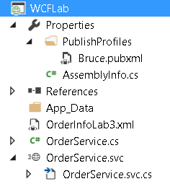

* Add these lines at the end of your client so I have time to read the windows

   Console.WriteLine("Enter CR To Exit");

 Console.ReadLine()

Your output is:

